Xiaoting Lian

New Romance of the three kingdoms

A game app is 3D real-Time multiplayer online strategy battle game based on parts of the history of China

Task 1

1. User have to transfer their data from BBgame to either Qoo or Dongfeng within three months.
2. Qoo is a Hongkong company and Dongfeng is a Taiwan Company. Both companies will be working together to operate this game. When you open your game’s login page, you will have the option that help you transfer your data to the new company based on your region. Since there are two companies, therefore, they have two apps that are the same except the login page is different.
3. Some of users’ data was not found during these three months, after user transferred their data, and logged in to the game, lots users’ game data was showed at beginning of the game. After both companies’ investigation, it happens because of the region problem, when you are in Taiwan, which is Dongfeng company runs it. The game’s login information is different from Qoo, the Hongkong company. User had to contact customer service to fix their problem.

Task 2

1. game events on Wednesday and Friday, most of the gamer will join this event.
2. During the event time, user need to move their character to specific location to join the event.
3. Large amount of user is playing the game, it might be lagging. This problem might cause by user’s weak internet connection, or the server speed is so slow, or too far from the server, since the server is from mainland China.

Task 3

1. User have to type in their login information every time when they want to play the game in different device.
2. The game was unable to save user’s login information. The words in the picture says” your login information is expired, please reenter"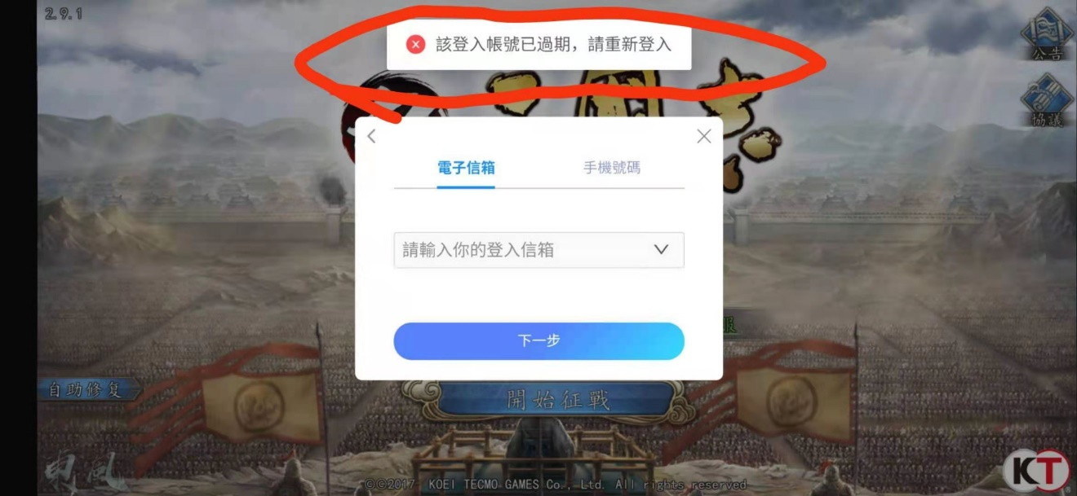
3. This problem might cause by the app is not be able to read the data from server or the game’s code have bug that they didn’t fix.